SE 126
Lab #5

5A. The file Lab5A.txt contains a list of IP address. Write a program that will load the IP addresses into a list. After all data has been read into the list print only the class B addresses along with the subnet mask 255.255.0.0.

Grading Criteria for Lab 5A
 | Points
Comments | 5
Program access the file correctly | 10
Program loads data into arrays | 15
The program uses a function to display only the class B addresses with the subnet mask | 30
Output is formatted correctly (see sample output) | 20
Program runs without errors | 20
Total | 100

5B. The file lab5b.csv is arranged in the following manner:

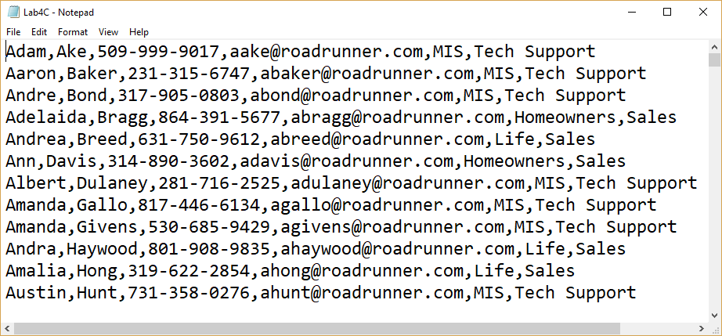
Field | Represents
0 | Employee’s first name
1 | Employee’s last name
2 | Phone number
3 | Email address
4 | Department
5 | Employee’s position in the department
Using the “sequential search” write a program that changes the email address for all employees who work in the MIS Department. Currently all employees “top-level-domain (TLD) is .com. .com should be changed to .net for all employees in the MIS Deplartment. You must use a sequential search. You may use a for loop or a while loop when searching. Before the progrqam exits display the number of addresses that were changed. You must use a function that searches for the email address and a function that changes the email address.

Grading Criteria for Lab 5B

 | Points
Comments: | 5
Program places data into arrays before processing | 10
A sequential search is used lookup email addresses | 25
The correct addresses are changed to .net | 30
Two functions were used. | 20
The number of addresses that were edited is displayed before the program exits. | 10
Total | 100

